EXNO: 3

Designing a Quarter wave transformer by varying following
parameters
a) frequency
b) input impedance
c) characteristic impedance
Test Case 1:
Design a quarter-wave transformer for an input impedance (Zin) of 50 ohms and a
load impedance (ZL) of 100 ohms. Analyze the transformer's performance as the
operating frequency is varied across {100 MHz, 200 MHz, 300 MHz, 500 MHz}.

OUTPUT:
ZR=100 ohms Zin =50 ohms
ZS ohms | ZR ohms | Ro ohms
100 | 50 | 70.71

ZR=100 ohms Zin =50 ohms
Frequency  (MHz) | Length of λ/4 transformer  (meters)
100 | 0.750
200 | 0.375
300 | 0.250
500 | 0.150

Simulation Results:
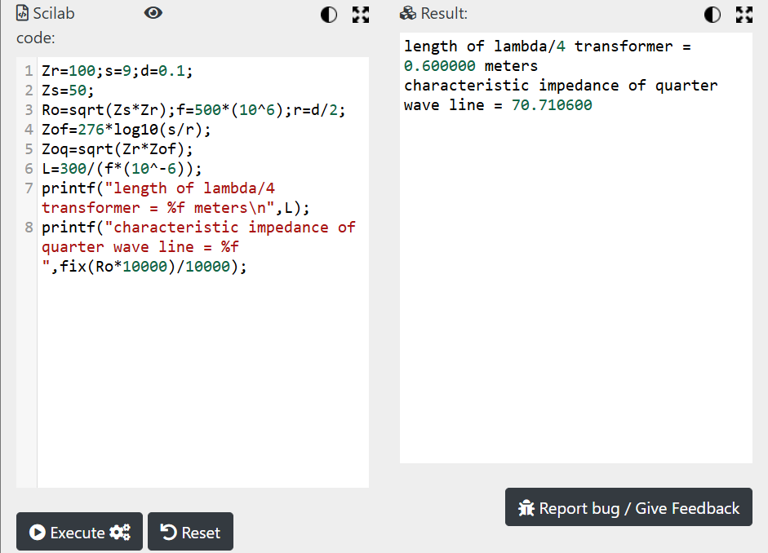

Theoretical Results
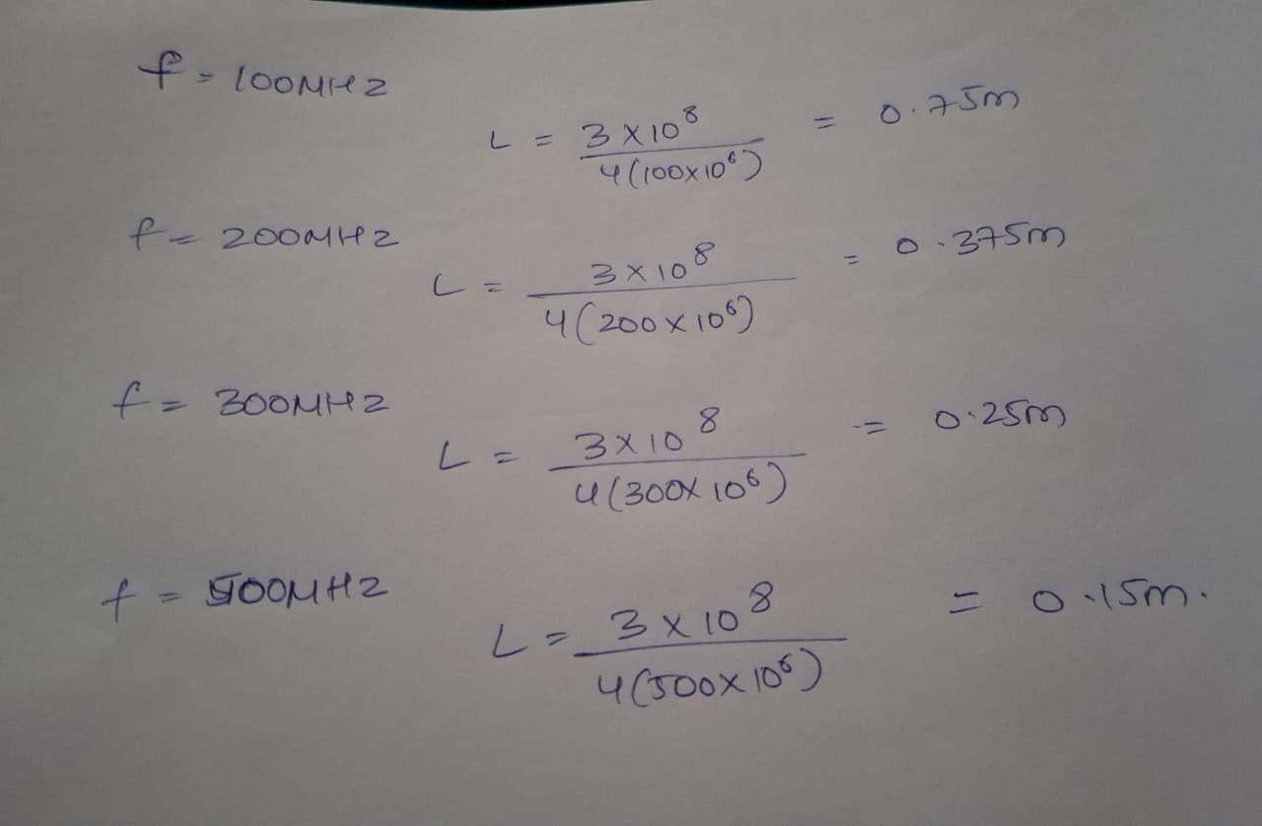
Test Case 2:
For a fixed operating frequency of 2 GHz and a load impedance (ZL) of 100 ohms,
design a quarter-wave transformer and evaluate its performance as the input
impedance (Zin) varies through {25 ohms, 50 ohms, 75 ohms, 100 ohms}. Validate
that the transformer's characteristic impedance (Ztransformer= Ro= sqrt(Zin⋅ZL)
changes with Zin.
OUTPUT:

ZR=100 ohms Variable: Zin
Zin | Ro
25 | 50
50 | 70.71
75 | 86.60
100 | 100.00

Simulation Results:
